**[Eye Gazed Virtual Keyboard Control System]**

**TECHNICAL REPORT**



**SUBMITTED BY**

Nabeel Hussain

2017-ag-8630

M.Umar Farooq

2017-ag-8693

Aqib Naseer

2017-ag-

**ADVISED BY**

[Mam Sidra Shahid]

**A TECHNICAL REPORT SUBMITTED IN PARTIAL FULFILLMENT OF REQUIREMENT FOR THE DEGREE OF**

*BACHELOR OF SCIENCE*

*IN*

*SOFTWARE EGNINEERING*

**DEPARTMENT OF COMPUTER SCIENCE**

**FACULTY OF SCIENCES**

**UNIVERSITY OF AGRICULTURE FAISALABAD**

**DECLARATION**

We hereby declare that the contents of the report [“**Eye Gazed Virtual Keyboard Control System**”] are project of our own research and no part has been copied from any published source (except the references). We further declare that this work has not been submitted for award of any other diploma/degree. The university may take action if the information provided is found false at any stage. In case of any default the scholar will be proceeded against as per UAF policy.

_________________

**CERTIFICATE**

To,

The Controller of Examinations,

University of Agriculture,

Faisalabad.

The supervisory committee certify that **[Nabeel Hussain] [2017-AG-8630],M.Umar Farooq[2017-ag-8694],** has successfully completed his project in partial fulfillment of requirement for the degree of Bachelor in Software Engineering under our guidance and supervision.

_____________________________________

[Mam Sidra Shahid]

Supervisor

_____________________________________

[Member Name]

Member

_______________________________________

Dr. Muhammad Ahsan Latif

Incharge,

Department of Computer Science

**ACKNOWLEDGEMENT**

We thank all who in one way or another contributed in the completion of this report. First, we thank to ALLAH ALMIGHTY, most magnificent and most merciful, for all his blessings. Then we are so grateful to the Department of Computer Science for making it possible for us to study here. Our special and heartily thanks to our supervisor, Mam Sidra Shahidwho encouraged and directed us. his challenges brought this work towards a completion. It is with his supervision that this work came into existence. For any faults we take full responsibility. we are also deeply thankful to our informants. we want to acknowledge and appreciate their help and transparency during our research. we are also so thankful to our fellow students whose challenges and productive critics have provided new ideas to the work. Furthermore, we also thank our family who encouraged us and prayed for us throughout the time of our research. May the Almighty God richly bless all of you.

**ABSTRACT**

The objective of the Eye gaze project is to use Eye gaze of the human by the means of interaction with the computer. As such, we have to develop a commercial computer system such that users will be able to operate computer based system by giving commands making use of his eye only.For instance to perform particular function such as to switch ON/OFF lights, the user activate control key on the screenin front of the function only by looking towards that key.The advantage of this system that there is no need of any physical connection between user and the system.This system is being developed for the people with the complex physical disabilities who are unable to make the use of their hands and can’t speak. This type of direct eye interface would increase an individual independence, dramatically improved quality of life of such people.It was first time introduced by Yarbus and known as Yarbus eye tracker in the 1960

Table of Contents

Chapter 1 - INTRODUCTION 5

1.1 Background: 5

1.2 Description: 5

1.3 Problem Statement: 5

1.4 Scope: 5

1.5 Objectives: 6

1.6 Feasibility: 6

1.7 Requirements: 7

1.7.1 Functional Requirements 7

1.7.2 Non- Functional Requirements 7

1.7.3 Hardware Requirements 8

1.7.4 Software Requirements 8

1.8 Stakeholders: 8

Chapter 2 – MATERIALS & METHODS 9

2.1 Process Model: 9

2.2 Tools & Technologies 9

2.3 Design: 9

2.3.1 Use Case Diagrams: 10

2.3.3 Sequence Diagram: 16

2.3.4 Class Diagram: 19

2.3.5 Data Flow Diagram: 20

2.3.6 ER Diagram: 24

2.3.7 Database Model: 24

2.3.8 Architecture: 25

Chapter 3 - RESULTS & DISCUSSION 27

3.1 Testing: 27

3.2 Test Cases: 27

3.3 Conclusion: 29

Chapter 4 - USER MANUAL 30

References 31

List of Figures

Figure ‎1.1 Stakeholders 8

Figure ‎2.1 Agile Activities 9

Figure 2.‎2 Use Case Diagram 12

Figure 2.3 Sequence Diagram 19

Figure 2.4 Class Diagram 20

Figure ‎2.5 Context Diagram 22

Figure ‎2.6 Level 0 DFD 22

Figure 2.7 Level 1 DFD 23

Figure ‎2.8 Entity Relationship Diagram 24

Figure 2.9 Database Model 25

Figure ‎2.10 Applications's Architecture 26

Figure ‎4.1 Signing in 30

List of Tables

Table 2. 1: Add User 15

Table 3. 1: User login Test Case 29

# Chapter 1 - INTRODUCTION

## 1.1 Background:

In the field of video analysis, several bio-metrics systems like-face detection, eye detection, iris

detection has gained significant consideration and are being appreciated in recent years. Those

systems are quite complicated because of some crucial dependencies like facial expression,

orientation, light, camera resolutions, etc. However, human eye is one of the most important and

eminent parts of the face and also convey different unique information of human. At present to form a more promising system “Eye detection” is another option. By detecting eye and tracking the movement of the eyeballs many useful interfaces can be developed. Due to the rapid development of technology, there is a great demand for Human-Computer Interaction. Many precious systems are being developed for people to make their life more secure and easy. But there was a need to develop such systems for the people who can’t work spontaneously, who are only able to perform any involuntary action. Many disabled people have only the action that they can perform of their own free will is the blinking of their eyes. Because of this, many human interaction systems are developing based on eye gaze. Eye-tracking systems use different types of image processing techniques like filtering, sharpening, etc. based on eye bio-metrics. In image processing, the input data is acquired first and then it is converted into digital form. In the digital image, various types of mathematical operations are applied to get a more enhanced image to perform the next operation. Various kinds of human-computer interfaces exist that make use of human eye movements and eye blinking. Some interfaces make use of eye movement for controlling the mouse cursor, some systems track eyes to check the drowsiness of the driver during a drive. Many eye-tracking techniques are also used in medicine and optometry to diagnose certain diseases. Eye gaze controlled virtual keyboard is an example of today’s developed technology. The idea behind the virtual keyboard is to display the keys in a rectangle form like a keyboard and continuously light up the keys one by one at time. Whenever the desired key light up, we would just need to close our eyes and the key will be pressed automatically. The face is known as the index of one’s mind while eyes are called windows to the soul of the human. The eyeball movement and blinking ratio provide an enriched window into a person’s intention and demand. Here, the eye-tracking system refers to the technique of measuring the movement/activity of eyes. To track the movement of eyes we have to detect eye and eyeball first. Again, face detection is the early step of eye detection. Accurately identification of landmarks within the face is a crucial step in the eye detection process. Tasks such as facial identification, expression analysis, age estimation, and gender classification are often built upon a facial land-marking component in their methods.

## 1.2 Description:

The eye gaze communication system is a communication system which is very useful for the blind persons with the help which they can perform their daily activities by using such a communication system. In other words, the Eye tracking is the process of measuring either the point of gaze(where one is looking) or the motion of an eye relative to the head. An eye trackeris a device for measuring eye positions and eye movement. Eye trackers are used in research on the visual system, in psychology, incognitive linguistics and in product design. There are a number of methods for measuring eye movement. The eyegaze System is a communication control system that you can run with your eyes.The Eyegazed System is a direct-select vision-controlled communication and control system.The motto of this paper clearly deals with the case study of eyegazed communication system

## 1.3 Problem Statement:

People who are crippled and disable or people who have only eyes as their potential cannot move their hands to type anything from physical keyboard. They can’t write and are unable to pick up any pen or to type by their fingers. For different type of physical disabilities, many students can’t continue their studies.

## **1.4Scope**

## This work will help afflicted people to type their text without touching the keyboard. Our main aim of this project is to minimize the effort for typing and to enable typing of those people who are crippled and are disable to type by using their finger. Some people have only eyes as their potential. They can’t write and are unable to pick up any pen or to type by their finger. For different types of physical disabilities, many students can’t continue their studies even can’t interact with others. Eye gaze controlled keyboard technology can give us the ability to help those students to continue their study and other work. It can help people to lead a normal human life.[1]

## 1.5 Objectives:

The main objective of this project is to minimize the effort of typing and to enable typing of those people who are crippled and disabled to type by using their fingers.

* **Goal**: Disabled or handicap people can interact with the computer by just blinking
* their eyes.
* **Objective**: To help disabled people
* **Objective**: To minimize the effort of typing

## 1.6 Feasibility:

The project that we are going to build is easy to use . As it does not need any physical keyboard or human hands or finger to type something instead it used virtual keyboard for interaction.

**1.6.1 Technical Feasibility** – Technical resources being used in the project are easy to use and cheap to use.

**1.6.2 Schedule Feasibility** – All the necessary resources are available. Project will be complete by the given deadline.

**1.6.3 Economic Feasibility** – As project is going to be developed by a small team and all the resources being used are cheap. So, the project is economically feasible.

**1.6.4 Cultural Feasibility** – Most of the people have access to a laptop with webcam or a PC with webcam. So, the system is implementable.

**1.6.5 Legal/Ethical Feasibility** – There is no legal or ethical restriction in making this system.

**1.6.6 Resource Feasibility** – Yes, user has enough resources to back the development of this system.

**1.6.7 Operational Feasibility** – There are tons of help on internet about every difficulty we feel on the course of development. So, I hope, this will be easy to build this project.

## Requirements:

### 1.7.1 Functional Requirements

Any requirement which precisely specifies what the system should do is called functional requirement of the system. In other words, a functional requirement will describe a particular behavior of function of the system when certain conditions are met.

#### FR01: Face Detection

|  |  |
| --- | --- |
| FR01-01 | System shall detect the human face |
| FR01-02 | System shall detect the 68 landmark points of face |

**FR02: Eye Detection**

|  |  |
| --- | --- |
| FR02-01 | System shall detect the eyes |
| FR02-02 | System shall draw rectangle around eyes |

**FR03: Eye gaze and Movement Detection**

|  |  |
| --- | --- |
| FR03-01 | System shall detect the gazing of eyes |
| FR03-02 | System shall detect the eyeballs movements and draw a dot on eyeballs |

**FR04: Eye Blinking Detection**

|  |  |
| --- | --- |
| FR04-01 | System shall detect the blinking of eyes |
| FR04-02 | System shall verify the blinking ratio |

**FR05: Display Virtual Keyboard**

|  |  |
| --- | --- |
| FR05-01 | System shall display a virtual keyboard on screen |
| FR05-02 | System shall highlight the virtual keyboard button one by one |

**FR06: Printing Words**

|  |  |
| --- | --- |
| FR06-01 | System shall detect the highlighted word |
| FR06-02 | System shall print the highlighted word on blinking of eyes |

### 1.7.2 Non- Functional Requirements

Any requirement which specifies how the system performs a certain function is called non-functional requirement. In other words, a non-functional requirement will describe how a System should behave and what limits there are on its functionality. Non-functional Requirements generally specify the system’s quality attributes or characteristics.

**NFR01**: Typing Accuracy

Typing accuracy of the system

should be maximum

**NFR02**: Response Time

System response time should

be minimum when eye is

blinked on a highlighted word

for printing that word.

**NFR03**: Performance

System should also perform

well on multiple faces.

**NFR04**: Usability

System should be easy to use

### 1.7.3 Hardware Requirements

Following are the minimum hardware requirements to use Eye Gazed Control Virtual Keyboard on user’s side:

* Processor: Core i3 CPU or higher
* Hard Disk: 10 GB or more
* RAM: 4 GB or more
* GPU: Gigabyte GV-N710D5-2GL NVIDIA Get Force GT 710Video Graphics Card
* Network: Network Interface Card, Working Internet Connection

### 1.7.4 Software Requirements

Following are the software requirements for Eye Gazed Control Virtual Keyboard:

Operating System: Windows 7or Higher

Webcam: Resolution min 720p

## Stakeholders:

**Project stakeholders** are entities that have an interest in each project. These stakeholders may be inside or outside an [organization](https://en.wikipedia.org/wiki/Organization) which:

1. [sponsor](https://en.wikipedia.org/wiki/Executive_sponsor) a project, or
2. have an interest or a gain upon a successful completion of a project.
3. may have a positive or negative influence in the project completion.

We need to understand that it is the actual user who will eventually use the system and hence accept or reject the product. Therefore, ignoring the needs of any user class may result in the system failure. Below picture depicts involvement level of different categories of stakeholders.

The following are examples of project stakeholders:

* Project leader
* [Senior management](https://en.wikipedia.org/wiki/Senior_management)
* [Project team](https://en.wikipedia.org/wiki/Project_team) members
* [Resource](https://en.wikipedia.org/wiki/Resource_(project_management)) Managers
* Product user group

# Chapter 2 – MATERIALS & METHODS

## 2.1 Process Model:

Incremental Model is a process of software development where requirements are broken down into multiple standalone modules of software development cycle. Incremental development is done in steps from analysis design, implementation, testing/verification, maintenance.

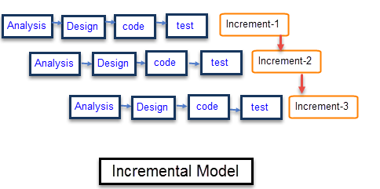

*Figure 2.1 Incremental Model*

## 2.2 Tools & Technologies

Tools & technologies to be used in project development.

* Visual studio code
* Jupyter Notebook
* Python
* Computer Vision
* Numpy
* Dlib(Digital Library)
* Pyglet

Following tools will be used in this System.

a) **Python**

Python is an interpreted, high-level, general-purpose programming language. Its language constructs and object-oriented approach aim to help programmers write clear, logical code for small and large-scale projects. Python is dynamically typed and garbage-collected. It supports multiple programming paradigms, including structured (particularly, procedural), object-oriented, and functional programming.

**b)Computer Vision**

Computer Vision is a field of artificial intelligence that train computer to interpret and understand the visual world.Using digital images from cameras and videos and deeplearning models, machines can accurately identify and classify objects and then react to what they ‘see’.

**c)Numpy**

Numpy is a python library that provides a simple yet powerful data structure:the n-dimentional array.This is the foundation on which almost all the power of python’s data science toolkit is built, and learning numpy is the first step on any python data scientist’s journey.

**d) Dlib(Digital library):**

It's a landmark's facial detector with pre-trained models, the dlib is used to estimate the location of 68 coordinates (x, y) that map the facial points on a person's face like image below. These points are identified from the pre-trained model where the iBUG300-W dataset was used.

**e)Pyglet:**

pyglet is a cross-platform windowing and multimedia library for Python, intended for developing games and other visually rich applications. It supports windowing, user interface event handling, game controllers and joysticks, OpenGL graphics, loading images and videos, and playing sounds and music. pyglet works on Windows, OS X and Linux.

**2.3 Design:**

Note: Below we added some design according to our project.

### 2.3.1 Use Case Diagrams:

A use case is a functionality the users need from the system. A use case diagram depicts the relationships among the actors and use cases. Generally, a single use case is supposed to cover all the actions or events that an actor can perform on the system at one go. The size of use case should not be very large or very small. For example, *Add User, Manage Profile, View Sales Report, Update Order* etc. are good medium size use cases. Whereas *Enter Password, Display Error Message* etc. are very small use cases and *Manage Sale & Purchase* is a very large use case.

The components in a use case diagram include:

Actors:

Actors are first thing you need to find for the use case diagram. Actors represent external entities of the system. These can be people or things, such as external hardware that interact with the system. For example, if an online store is being modeled there can be more than one actor that interacts with the store functionality. Such as the Customer and stocker will be the actors in the system. It is represented simply by a stick figure with its name at the bottom of it.



*Actor*

Use Cases:

Use cases are functional parts of the system. They figure out what actions/functionalities a user will perform. Use cases are basically the functional requirements that you have pointed out in the functional and non-functional requirements topic. For example: The customer "browses the catalog", "chooses items to buy", and "pays for the items". Here browse catalog, buy item and pay for item are the use cases. Many actors can share a single use cases. The notation for a use case is an ellipse. As it is displayed below:

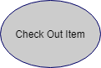

Associations:

Associations between actors and use cases are indicated in use case diagrams by solid lines. An association exists whenever there is direct interaction between actor and use case.   Associations are modeled as lines connecting use cases and actors to one another, with an arrowhead on one end of the line.



System boundary:

System’s boundary is drawn by a rectangle that contains use cases. The actors are placed outside the system boundary and use cases inside it.

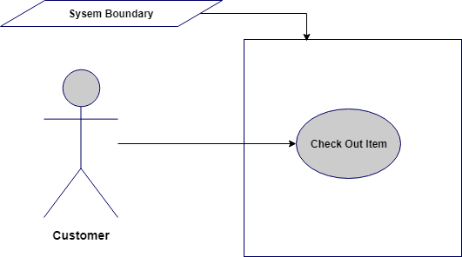

**Relationship between Use cases:**

1. **Include/Uses:**

Include relationship is a relationship in which one use case (the base use case) includes the functionality of another use case (the inclusion use case). <<include>> use cases must be **used** by the use cases that **use** them before the latter can be complete. It is displayed in the diagram editor as a dashed line with an open arrow pointing from the base use case to the inclusion use case. The keyword «include» is attached to the connector.

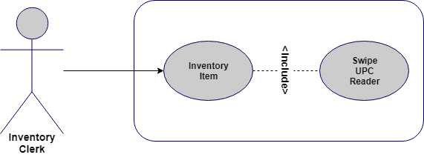

1. **Extend:**

A use case **extends** another use case to do more than the latter. It extends the functionality of one use case to further level. is displayed in the diagram editor as a dashed line with an open arrowhead pointing from the extension use case to the base use case. The arrow is labeled with the keyword «extend».

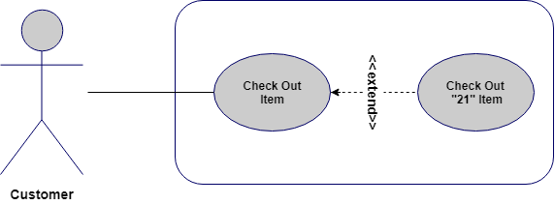

**Use Case Diagram:**

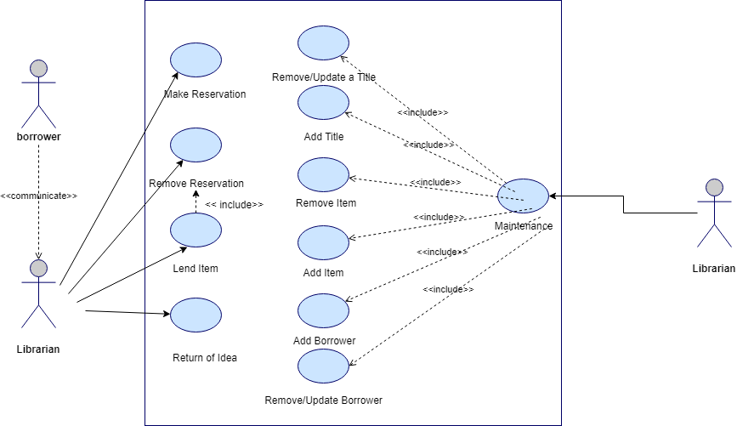

*Figure 2.2 Use Case Diagram*

**2.3.2 Usage Scenario**

Usage scenario is the actual text-based representation of the use case, among various representation methods discussed above. A usage scenario is likely to have various sections depending upon the level of details required in a given system. There is no fixed standard so far for number of sections in a use case (usage scenario).

Following is a typical table structure for usage scenario, note that it is not mandatory to write a usage scenario in the table format only, and it is likely that you will find different structures for the same representation.

|  |  |  |
| --- | --- | --- |
| **Use Case Title** | **Write Title Here (must match use case title in use case diagram)** | |
| **Abbreviated Title** |  | |
| **Use Case Id** |  | |
| **Requirement Id** |  | |
| **Description:** | | |
| **Pre Conditions:** | | |
| **Task Sequence** | | **Exceptions** |
|  | |  |
|  | |  |
|  | |  |
| . | |  |
| . | |  |
| **Post Conditions:** | | |
| **Unresolved issues:** | | |
| **Authority:** | | |
| **Modification history:**  **Author:**  **Description:** | | |

Let’s explore each section from the template provided above. (you have to make only usage scenario tables, below is description of its each part)

* **Use Case Title**

It is the name or label of the use case for which we are writing the usage scenario. Generally it must start with a Verb and it should consist of 2 to 4 words e.g. *Add User, Manage User Roles* etc.

|  |  |
| --- | --- |
| **Use Case Title** | **Add User** |

* **Use Case Id**

Sometimes use cases are indexed for better reference in overall project documentation/artifacts. This can be any form of series e.g. 1, 2, 3 etc. Priority based use case id is another famous use for this section. Use cases are indexed to present their importance in the system. You would want to set ascending or descending rating or priority for all use cases i.e. the most important use cases are ranked higher so that the project team knows what should be implemented first in the upcoming phases/deliverable of the project.

* **Requirement Id**

The purpose of this section is same as ‘Use Case Id’ section. The number written against this section represents the corresponding functional requirements this use case belongs to. It is compulsory to index all the functional requirements properly before this section can be used:

|  |  |
| --- | --- |
| **Requirement Id** | 3 |

* **Description**

It should be a very brief description of the use case under discussion. Generally this portion should consist of 2/3 lines.

|  |  |
| --- | --- |
| **Description** | This use case is about adding a new user to existing system with the privileges defined at time of user account creation. |

* **Pre-Conditions**

This section should enlist what must be true before this use case can be performed.

|  |
| --- |
| **Pre Conditions:**   * 1. All must-required information about the new user should be available.   2. Database should be available in online mode. |

* **Task Sequence & Exceptions**

This is the most important section of the usage scenario. It is also referred as Success Scenario, Actions, (or simply) Scenario. This should be a list of actor’s interaction with the use case.

|  |  |
| --- | --- |
| **Task Sequence** | **Exceptions** |
| 1. Administrator opts to Add a new user account. |  |
| 1. System asks for necessary information |  |
| 1. Administrator provides all the required information and opts to complete the operation. |  |
| 1. System after confirmation adds the new account. |  |
| 1. System sends the account creation email to the administrator’s email id and user’s email address. |  |
| 1. A log is saved on the successful operation of the use case. |  |

Alternate scenarios could be more than one; in this case, it will be better to make a bold heading to show each alternate scenario separately. Again, there can be multiple ways to show the alternate scenarios.

Exceptions are any unhandled scenarios that must be discussed under this section. Sometimes there are ambiguous situations in start of project that might hurdle the flow of events in the Task Sequence portion. In such situations the details are provided in the Exceptions section. Generally, this section should be left blank as in case of final project, you will get fixed requirements at the start and thus there should be no ambiguity.

* **Post Conditions**

The conditions that must be true depending upon the successful use case are mentioned in this section.

|  |
| --- |
| **Post Conditions:**   * + - A new user account is successfully created. |

* **Unresolved Issues**

In addition to the Exceptions portion, we write unresolved issues (if any) in this section, so that in later phases (when the situation gets more clear).

Just like Exceptions section, this will be generally left blank (or its row can be deleted from the use case table-structure.

* **Authority**

The role that is allowed to perform this use case, in our current example it will be Administrator.

* **Modification History**

If a use case is updated in later stages of the project development, the versioning information should be mentioned in this section (version can be a series such as 1.0, 2.0, 3.0 or 1.1, 1.2, 1.3 etc.)

* **Author**

It means the author of this usage scenario. Put your project/group id in this section.

* **Description**

Any more details about author, revision of the use case should be provided in this section.

So final usage scenario is as follows:

Table 2. 1: Add User

|  |  |  |
| --- | --- | --- |
| **Use Case Title** | Add User | |
| **Use Case Id** | 1 | |
| **Requirement Id** | 3 | |
| **Description:** This use case is about adding a new user to existing system with the privileges defined at time of user account creation. | | |
| **Pre Conditions:**   * 1. All must-required information about the new user should be available.   2. Database should be available in online mode. | | |
| **Task Sequence** | | **Exceptions** |
| 1. Administrator opts to add a new user account. | |  |
| 1. System asks for necessary information. | |  |
| 1. Administrator provides all the required information and opts to complete the operation. | |  |
| 1. There is a problem in the data provided; some data needs to be corrected.    * Administrator checks the available information and corrects the error.    * Administrator continues from the step 3. | |  |
| 1. System after confirmation adds the new account. | |  |
| 1. System sends the account creation email to the administrator’s email id and user’s email address. | |  |
| 1. A log is saved on the successful operation of the use case. | |  |
| **Post Conditions:**   * + A new user account is successfully created. | | |
| **Unresolved issues:** | | |
| **Authority:** Administrator | | |
| **Modification history: 1.0**  **Author: <Project or Group ID>**  **Description:** | | |

**Important Points:**

* + - There should be a usage scenario for each use case from use case diagram e.g. if there are (let say) 10 use cases in use case diagram, then there must be 10 separate usage scenarios (i.e. one for each).
    - Title of use cases in use case diagram and in the usage scenario must be same.
    - As said earlier, there is no standard for any fixed sections in usage scenario, so if you don’t have anything to write in a particular section, then just leave it blank or delete its row/cell from the table. It is important to note that some sections are very common across different representations of usage scenarios and such sections should not be removed/kept blank at all. These sections are: Use Case Title, Pre-Conditions, Post Conditions, Task Sequence, Author etc. Again, it all depends upon the situation and level of details required in a given system.
    - Generally, a good approach for Task Sequence portion is not to mention very small GUI level details such as:

‘Administrator clicked on Submit button’

OR

‘System shows the confirmation message’

### 2.3.3 Sequence Diagram:

A sequence diagram simply depicts interaction between objects in a sequential order i.e. the order in which these interactions take place. We can also use the terms event diagrams or event scenarios to refer to a sequence diagram. Sequence diagrams describe how and in what order the objects in a system function. These diagrams are widely used by businessmen and software developers to document and understand requirements for new and existing systems.

**Sequence Diagram Notations:**

**Actors –** An actor in a UML diagram represents a type of role where it interacts with the system and its objects. It is important to note here that an actor is always outside the scope of the system we aim to model using the UML diagram.  
**Class Roles or Participants:**  
Class roles describe the way an object will behave in context. Use the UML object symbol to illustrate class roles, but don't list object attributes.



**Activation or Execution Occurrence:**  
Activation boxes represent the time an object needs to complete a task. When an object is busy executing a process or waiting for a reply message, use a thin gray rectangle placed vertically on its lifeline.

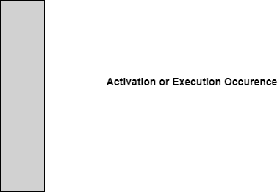

**Messages**  
Messages are arrows that represent communication between objects. Use half-arrowed lines to represent asynchronous messages. Asynchronous messages are sent from an object that will not wait for a response from the receiver before continuing its tasks. For message types, see below.

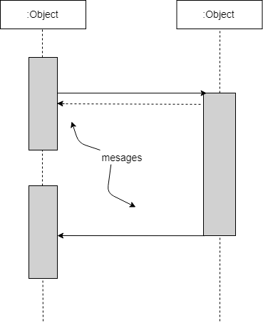

**Lifelines**  
Lifelines are vertical dashed lines that indicate the object's presence over time.

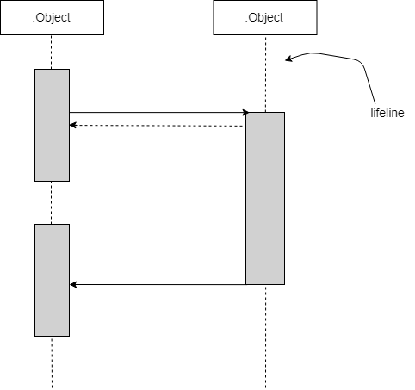

**Destroying Objects**  
Objects can be terminated early using an arrow labeled "<< destroy >>" that points to an X. This object is removed from memory. When that object's lifeline ends, you can place an X at the end of its lifeline to denote a destruction occurrence.

**Loops**  
A repetition or loop within a sequence diagram is depicted as a rectangle. Place the condition for exiting the loop at the bottom left corner in square brackets [ ].

**Sequence Diagram Example (for item return use case):**

Note: Make sequence diagram for each use case illustrated in use case diagram

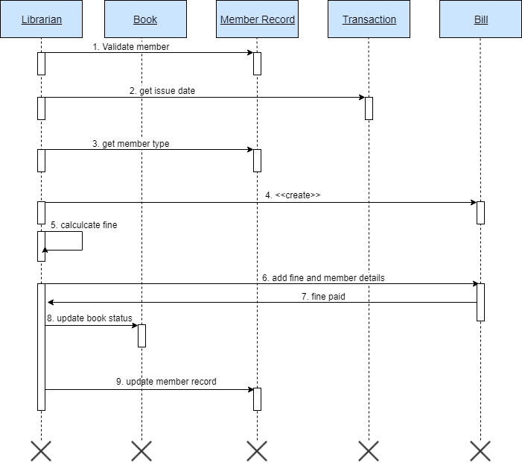

*Figure 2.3 Sequence Diagram*

### 2.3.4 Class Diagram:

A class diagram is a type of static structure diagram that describes the structure of a system by showing the system's classes, their attributes, operations (or methods), and the relationships among objects. For further reading visit: <https://creately.com/blog/diagrams/class-diagram-relationships/>. Below is the class diagram for library management system discussed above.

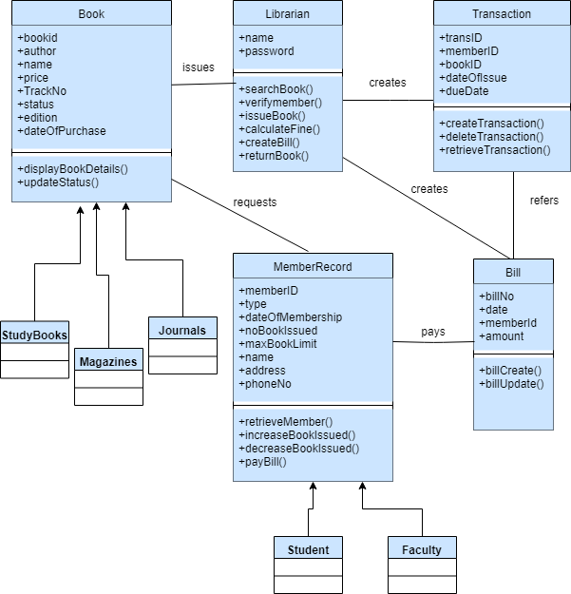

*Figure 2.4 Class Diagram*

### 2.3.5 Data Flow Diagram:

A data flow diagram (DFD) maps out the flow of information for any process or system. It uses defined symbols like rectangles, circles and arrows, plus short text labels, to show data inputs, outputs, storage points and the routes between each destination. A Data Flow Diagram (DFD) is traditional visual representation of the information flows within a system. A neat and clear DFD can depict a good amount of the system requirements graphically. It can be manual, automated, or combination of both.

It shows how information enters and leaves the system, what changes the information and where information is stored. The purpose of a DFD is to show the scope and boundaries of a system as a whole. It may be used as a communications tool between a systems analyst and any person who plays a part in the system that acts as the starting point for redesigning a system. [3]

It is usually beginning with a context diagram as the level 0 of DFD diagram, a simple representation of the whole system. To elaborate further from that, we drill down to a level 1 diagram with lower level functions decomposed from the major functions of the system. This could continue to evolve to become a level 2 diagram when further analysis is required. Progression to level 3, 4 and so on is possible but anything beyond level 3 is not very common. Please bear in mind that the level of details for decomposing particular function really depending on the complexity that function. For further reading use the link given below:

<https://www.visual-paradigm.com/guide/data-flow-diagram/what-is-data-flow-diagram/>

#### DFD Diagram Notations

#### External Entity

An external entity can represent a human, system or subsystem. It is where certain data comes from or goes to. It is external to the system we study, in terms of the business process. For this reason, people used to draw external entities on the edge of a diagram.



#### Process

A process is a business activity or function where the manipulation and transformation of data takes place. A process can be decomposed to finer level of details, for representing how data is being processed within the process.   


#### Data Store

A data store represents the storage of persistent data required and/or produced by the process. Here are some examples of data stores: membership forms, database table, etc.   
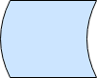

#### Data Flow

A data flow represents the flow of information, with its direction represented by an arrow head that shows at the end(s) of flow connector.

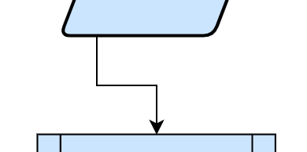

**Context Diagram:**

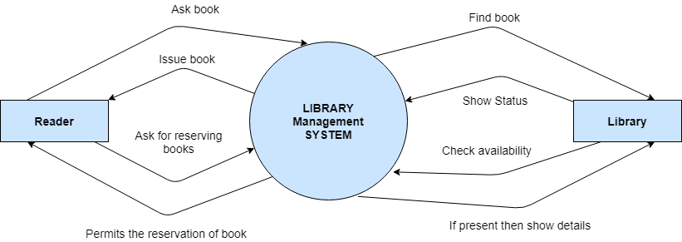

*Figure 2.5 Context Diagram*

**Level 0:**

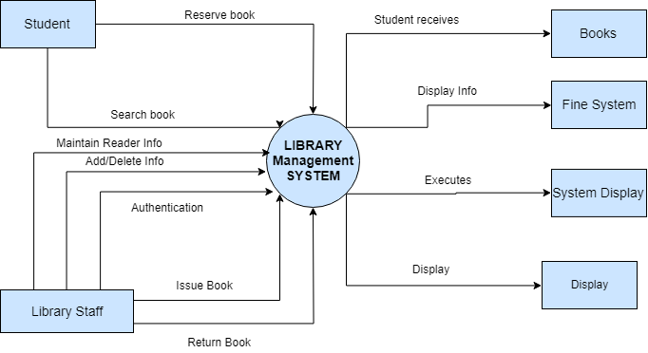

*Figure 2.6 Level 0 DFD*

**Level 1:**

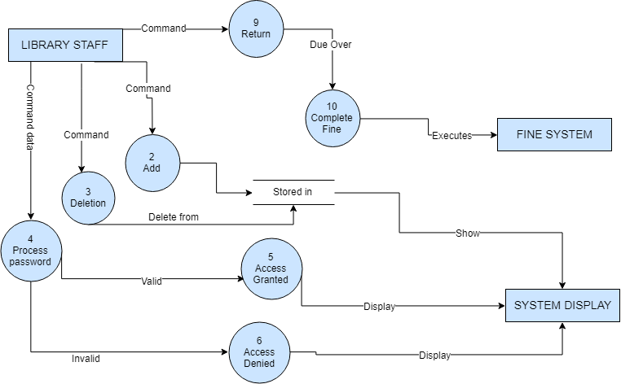

*Figure 2.7 Level 1 DFD*

**Also include Data Dictionary in this section.**

### 2.3.6 ER Diagram:

An entity relationship model, also called an entity-relationship (ER) diagram, is a graphical representation of entities and their relationships to each other, typically used in computing in regard to the organization of [data](https://www.webopedia.com/TERM/D/data.html) within [databases](https://www.webopedia.com/TERM/D/database.html) or information systems. An entity is a piece of data-an [object](https://www.webopedia.com/TERM/O/object.html)or concept about which data is stored. To learn more about ERD visit: <https://www.smartdraw.com/entity-relationship-diagram/>

Below is example of ERD between customer and invoices in any xyz E-Billing system.

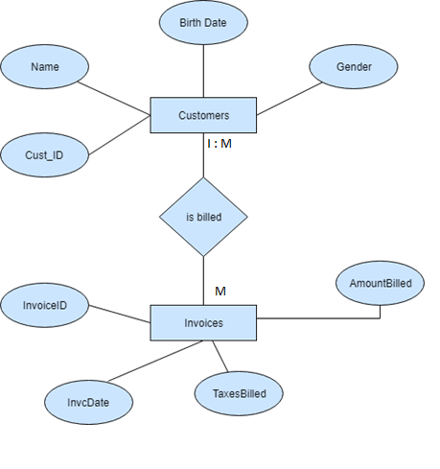

*Figure 2.8 Entity Relationship Diagram*

### 2.3.7 Database Model:

A database model shows the logical structure of a database, including the relationships and constraints that determine how data can be stored and accessed. Individual database models are designed based on the rules and concepts of whichever broader data model the designers adopt. Most data models can be represented by an accompanying database diagram. Below is an example for library management system. [4] To read more about designing database model visit: <https://www.datanamic.com/support/lt-dez005-introduction-db-modeling.html>



*Figure 2.9 Database Model*

### 2.3.8 Architecture:

**3-Tier: (or N- Tier/multitier, chose whatever best suits your project nature)**

A 3-tier architecture is a type of software architecture which is composed of three “tiers” or “layers” of logical computing. They are often used in applications as a specific type of client-server system. 3-tier architectures provide many benefits for production and development environments by modularizing the user interface, business logic, and data storage layers. Doing so gives greater flexibility to development teams by allowing them to update a specific part of an application independently of the other parts. This added flexibility can improve overall time-to-market and decrease development cycle times by giving development teams the ability to replace or upgrade independent tiers without affecting the other parts of the system.

**Presentation Tier-** The presentation tier is the front-end layer in the 3-tier system and consists of the user interface. This user interface is often a graphical one accessible through a web browser or web-based application and which displays content and information useful to an end user. This tier is often built on web technologies such as HTML5, JavaScript, CSS, or through other popular web development frameworks, and communicates with other layers through API calls.

**Application Tier-** The application tier contains the functional business logic which drives an application’s core capabilities. It’s often written in Java, .NET, C#, Python, C++, etc.

**Data Tier-** The data tier comprises of the database/data storage system and data access layer. Examples of such systems are MySQL, Oracle, PostgreSQL, Microsoft SQL Server, MongoDB, etc. Data is accessed by the application layer via API calls.

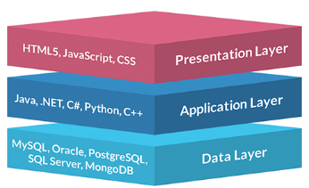

*Figure 2.10 Application Architecture*

# Chapter 3 - RESULTS & DISCUSSION

In this chapter discuss overall performance or all functional and non-functional requirements you listed in chapter no. 1 as this section will verify the performance measures proposed for this project. For this software testing plays a vital role.

## 3.1 Testing:

Software testing is a process, to evaluate the functionality of a software application with an intent to find whether the developed software met the specified requirements or not and to identify the defects to ensure that the product is defect free in order to produce the quality product. In this regard, Test case writing is a major activity and considered as one of the most important parts of software testing. It is used by the testing team, development team as well as the management. If there is no documentation for an application, we can use test case as a baseline document. Below are some suggestions for writing good test cases:

## 3.2 Test Cases:

**Test cases need to be simple and transparent**

Create test cases that are as simple as possible. They must be clear and concise as the author of the test case may not execute them.

Use assertive language like go to the home page, enter data, click on this and so on. This makes the understanding the test steps easy and tests execution faster.

**Create Test Case with End User in Mind**

The ultimate goal of any software project is to create test cases that meet customer requirements and is easy to use and operate. A tester must create test cases keeping in mind the end user perspective

**Avoid test case repetition.**

Do not repeat test cases. If a test case is needed for executing some other test case, call the test case by its test case id in the pre-condition column

**Do not Assume**

Do not assume functionality and features of your software application while preparing test case. Stick to the User Requirement Specification Documents.

**Ensure 100% Coverage**

Make sure you write test cases to check all software requirements mentioned in the specification document.

**Test Cases must be identifiable.**

Name the test case id such that they are identified easily while tracking defects or identifying a software requirement at a later stage. [2]

**Test Case Template Help:**

* Test case ID: Unique ID is required for each test case.
* Test Title/Name: Test case title. E.g. verify login page with a valid username and password.
* Test priority (Low/Medium/High): This is very useful while test execution. Test priority for business rules and functional test cases can be medium or higher whereas minor user interface cases can be of a low priority. Test priority should always be set by the reviewer.
* Requirements: Requirements for which this test case is being written for. Preferably the exact section number of the requirement doc.
* Test Summary/Description: Describe the test objective in brief.
* Test Execution Date: Date when the test was executed.
* Pre-conditions: Any prerequisite that must be fulfilled before the execution of this test case. List all the pre-conditions in order to execute this test case successfully.
* Dependencies: Mention any dependencies on the other test cases or test requirement.
* Test Steps: List all the test execution steps in detail. Write test steps in the order in which they should be executed. Make sure to provide as many details as you can. Tip – In order to manage a test case efficiently with a lesser number of fields use this field to describe the test conditions, test data and user roles for running the test.
* Test Data: Use of test data as an input for this test case. You can provide different data sets with exact values to be used as an input.
* Expected Result:  What should be the system output after test execution? Describe the expected result in detail including message/error that should be displayed on the screen.
* Post-condition: What should be the state of the system after executing this test case?
* Actual result: Actual test result should be filled after test execution. Describe the system behavior after test execution.
* Status (Pass/Fail): If actual result is not as per the expected result, then mark this test as failed. Otherwise, update it as passed.
* Notes/Comments/Questions: If there are some special conditions to support the above fields, which can’t be described above or if there are any questions related to expected or actual results then mention them here. [3]

**Test Case: User Login:**

Below is test case format:

Table 3. 1: User login Test Case

|  |  |
| --- | --- |
| **Test Case ID:** | **1 or TC-1** |
| **Test Case Title:** | To verify the Login functionality of the application |
| **Test Case Priority:** | High |
| **Requirement:** | User Login |
| **Test Description:** | This test will verify the user login process. |
| **Test Date:** | mm/dd/yyyy |
| **Pre-Conditions:** | 1. Run the application.  2. Click Sign in button. |
| **Dependencies:** | Internet Availability |
| **Test Steps:** | 1. Enter Valid user name and password and click Login  2. Click Sign Out  2. Without entering user name click sign in  3. Without entering password click sign in  4. Enter wrong password or user name and click sign in |
| **Test Data** | Email id and password of user |
| **Expected Results:** | 1. System should open home page.  2. Login page should be displayed.  2. An error message should be shown to enter user name  3. An error message should be shown to enter password  4. Error message should be shown to enter correct password and user id |
| **Actual Results:** | As above |
| **Post Conditions:** | System shows Dash board page of signed in user. In case of unauthorized sign in attempt system shows the message “Invalid username/password”. |
| **Status: (Pass/Fail)** | Pass |
| **Other Comments:** | None |

Similarly, continue Test Cases designing as above for your application. Create a test case for each of the usage scenario provided in initial phases. [4]

## 3.3 Conclusion:

In the end of this chapter, this section will conclude the overall performance and results of test cases, how many of them resulted in Pass or satisfactory status. Also, it will include the look and feel or UI/UX aspects of the software. Whether UI is user friendly or much technical to use. Discuss all possible aspects. (At least 350 words)

# Chapter 4 - USER MANUAL

The system was implemented in real-time and all implementation results were recorded. Here, we represent all of the recorded results with respective figures.

A. **Face and Eye detection**

After running the program web camera of the pc is opened.The first step of the system is face detection. So, face detection in real-time implemented using Haar based HoG feature descriptor and to detect eye we use facial landmarks method with dlib.

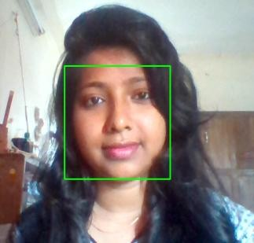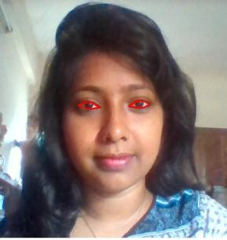 **Fig**. **9. (a) Face detection (b) Eye region detection**

**B. Eye Gaze Detection**

To detect eye gaze we calculate eye gaze ratio from both left and right eye. We detect the screening point at which eyeball is looking. We can only define eye gaze as the center, right

and left. To select the keyboard part we have to use eye gaze. If we look at the right and close our eyes for some time, the right part of the keyboard will open and if we look at the left part left side will open.

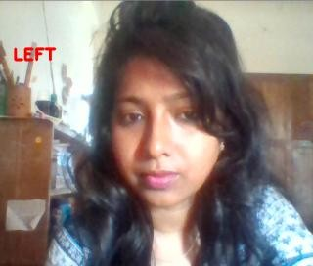 



**Fig. 10. Eye (a) Gaze on left side (b) Gaze on center (c)**

**C.Eye Blinking Detection**

The main task of the system is typing which is done by eye blinking. Here the eye area is taken from the video stream and then we apply a threshold to detect eye-ball more accurately. We calculate the eye blinking ratio to differentiate between the normal eye blinking and the desired blinking type. We set a value as 5 and compare it with the blinking ratio. Whenever the blinking ratio is more than 5, key from the keyboard is printed on the whiteboard. Left eye, area after applying threshold and blinking is shown below:

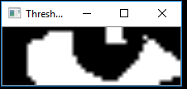

***Fig.*****11.*****Eye ball detection (a) Left eye (b) After applying threshold***

*Open eyes and blinking eyes figure:*

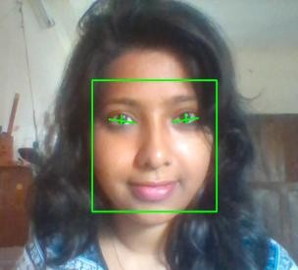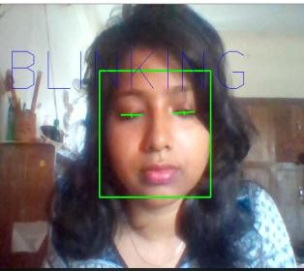

**Fig. 12.****Blinking detection (a) Open eyes (b) Eyes blinking**

**D. Keyboard Selection**

To select the left or right side of the keyboard we calculate gaze ratio. If the gaze ratio is more than 0.9 (constant value) left side of the keyboard will be opened otherwise right side will open. In this case, we have look at the left or right side and close our eyes for some moment that is around a second or more to open the keyboard. Implementation results are shown in Fig. 13.

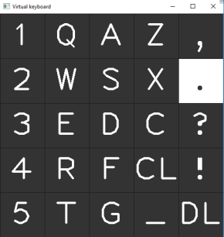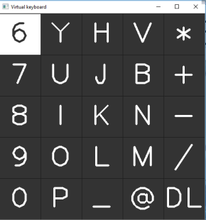

**Fig. 13. Keyboard (a) First look of the keyboard (b) Left side of the**

**keyboard (c) Right side of the keyboard**

**E.Key Selection and Writing**

Each key of the keyboard is lighted up. Mainly we are lighting up each key for 10 frames and then the next one. Thus, when our desired key is lighted up we just have to close our eyes for around seconds and the key will appear on the board shown in Fig.

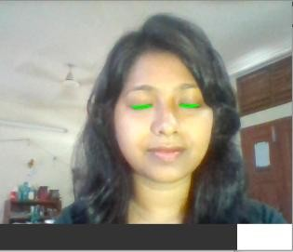 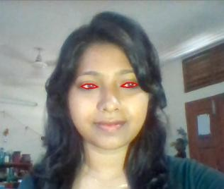

## board.PNG Fig. 14. (a) Looking at the keyboard (b) Selecting key by closing

**eyes (c) Writing on the board**

**F. Results**

We have run our program several times and compared all the results. The system is not 100\% accurate. Though our key selection with eye blinking is much accurate, eye gaze detection as the right or left side is poor. However, this limitation is possible by using a high-resolution camera.

## Table- I: Results summary

|  |  |
| --- | --- |
|  |  |
|  |  |
|  |  |
|  |  |
|  |  |

**Formatting instructions:**

Following formatting is already applied on the document. However, it is explicitly mentioned below:

* Minimum length of the Report: 30 pages
* Font style : Times New Roman
* Paragraph font size: 12pt
* Main Heading Size: 14pt + Bold (before and after spacing 12pt)
* Sub Heading Size: 13pt + Bold (before and after spacing 8pt)
* Sub sub heading size 12pt + bold (before and after spacing 6pt)
* Paragraph Alignment: Justified
* Picture/Chart Alignment: Center
* Picture/chart/table heading font: Times New Roman
* Picture/chart/table heading font size: 10pt, Italic, center alignment
* Picture caption goes under the picture without any extra line and line space
* Table caption goes above the table without any extra line and line space
* Table heading: Times New Roman, 10pt, Bold
* Table text: Times New Roman, 10pt
* Line Spacing: 1.15
* Left/Right/Top/Bottom Margins: 1 inch
* Table of Contents, List of Tables, List of Figures Heading: Times New Roman. 14pt, Bold
* Table of Contents, List of Tables, List of Figures: Times New Roman. 12pt
* For Table of Contents, List of Tables & List of Figures use Roman number as page number format in footer (center align)
* For Introduction onwards, use integer number as page number format in footer (center align)

**For Submission:**

**Three hard binded copies of technical report are required with memory card (attached with each copy) containing technical report and project (exe file + all source code).**